**VECTR v5.1.2 Feature Breakdown**

Table of Contents

Reporting Screen 2

User Management 4

Tagging Management 6

System Flags 8

# Reporting Screen

What is it?

Single reporting view that allows you to cycle through reporting views and view aggregations of Assessments and Campaigns, along with filtering on status/outcomes.

How does it work?

You can access the Reporting screen by selecting the Reporting tab on the Left Nav:

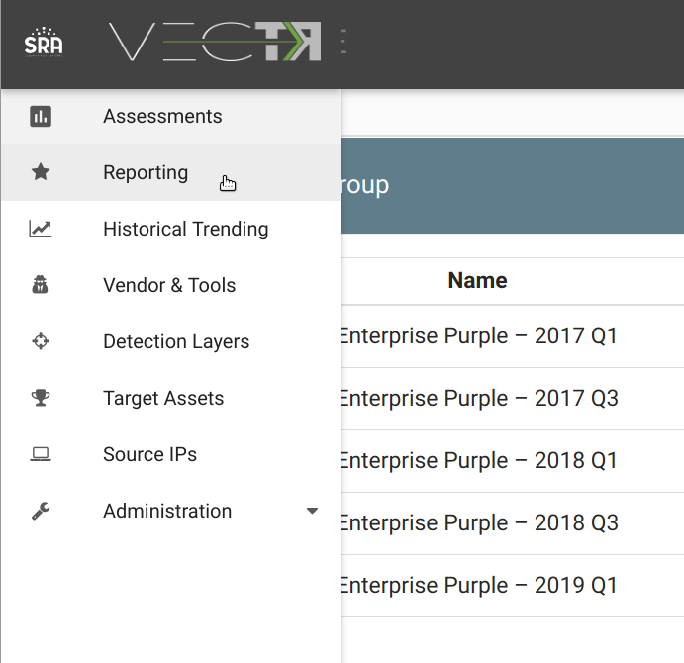

This will take you to the Reporting View:

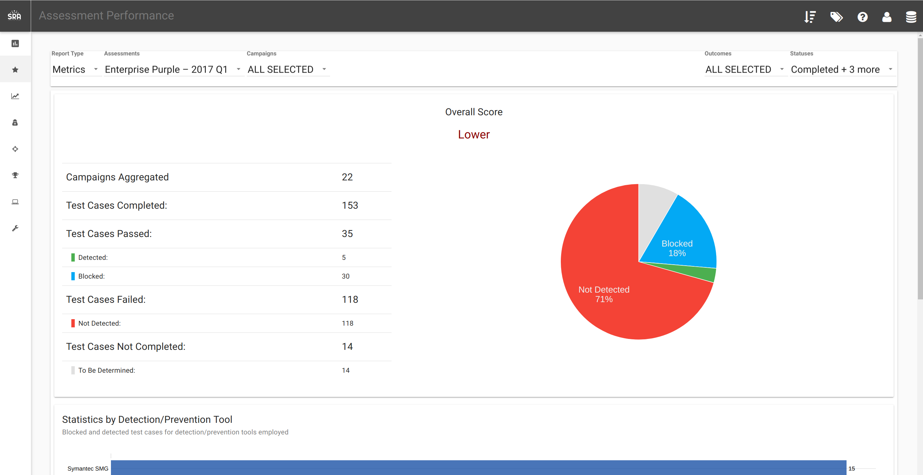

The top of the page lets you select the report type and aggregate/filter data:

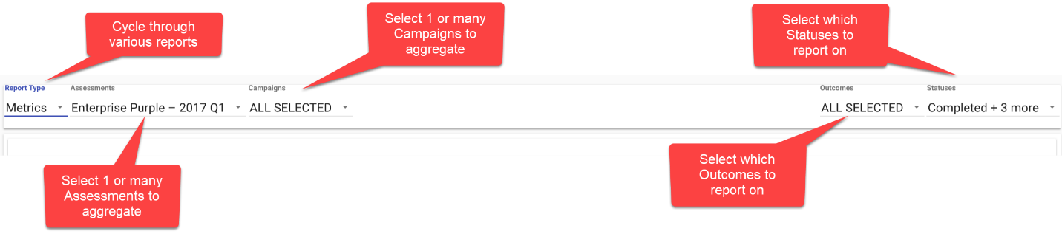

You can get to the Reporting screen with the proper Assessment selected by clicking the reporting icon in the Assessment Group selection screen:

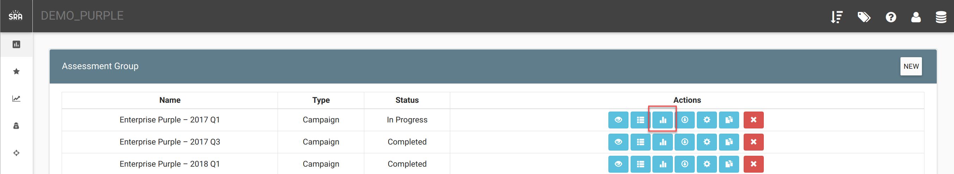

You can get to the Reporting screen with the proper Assessment and Campaign selected by clicking the reporting icon in the Campaign selection screen:

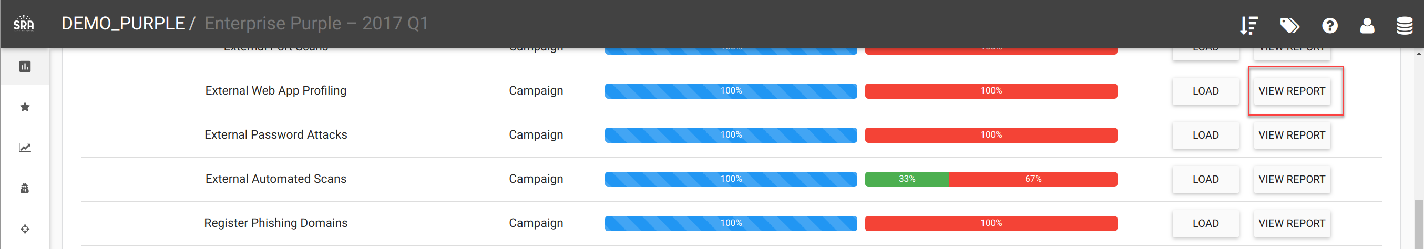

# User Management

What is it?

Allows for an ADMIN to add users with either the Role of USER or ADMIN. Users with USER will be able to use the platform, but not create users or escalate Roles.

How does it work?

You can access the User Management screen by selecting the User Management tab on the Left Nav:

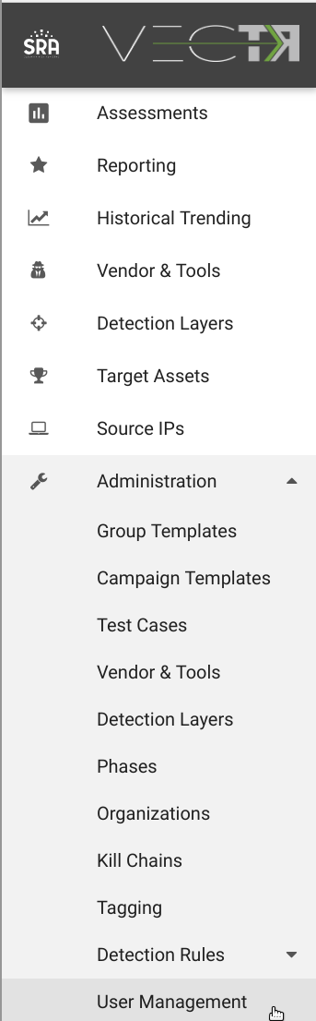

This will take you to the User Management page.

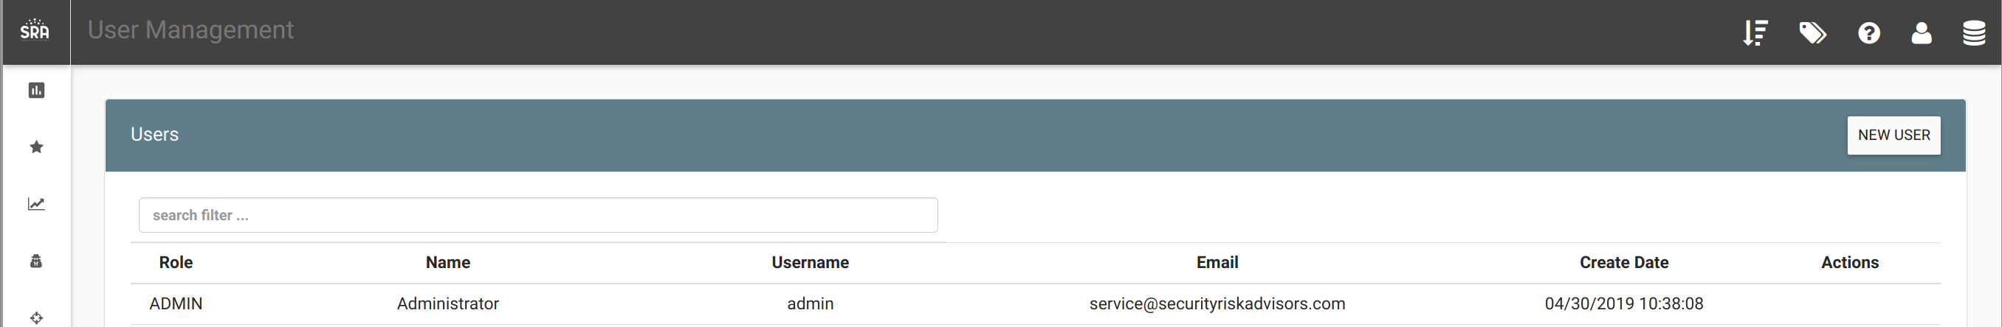

If you’re logged in as a user with Role “ADMIN”, you can create new user by clicking the “New User” button in the top right.

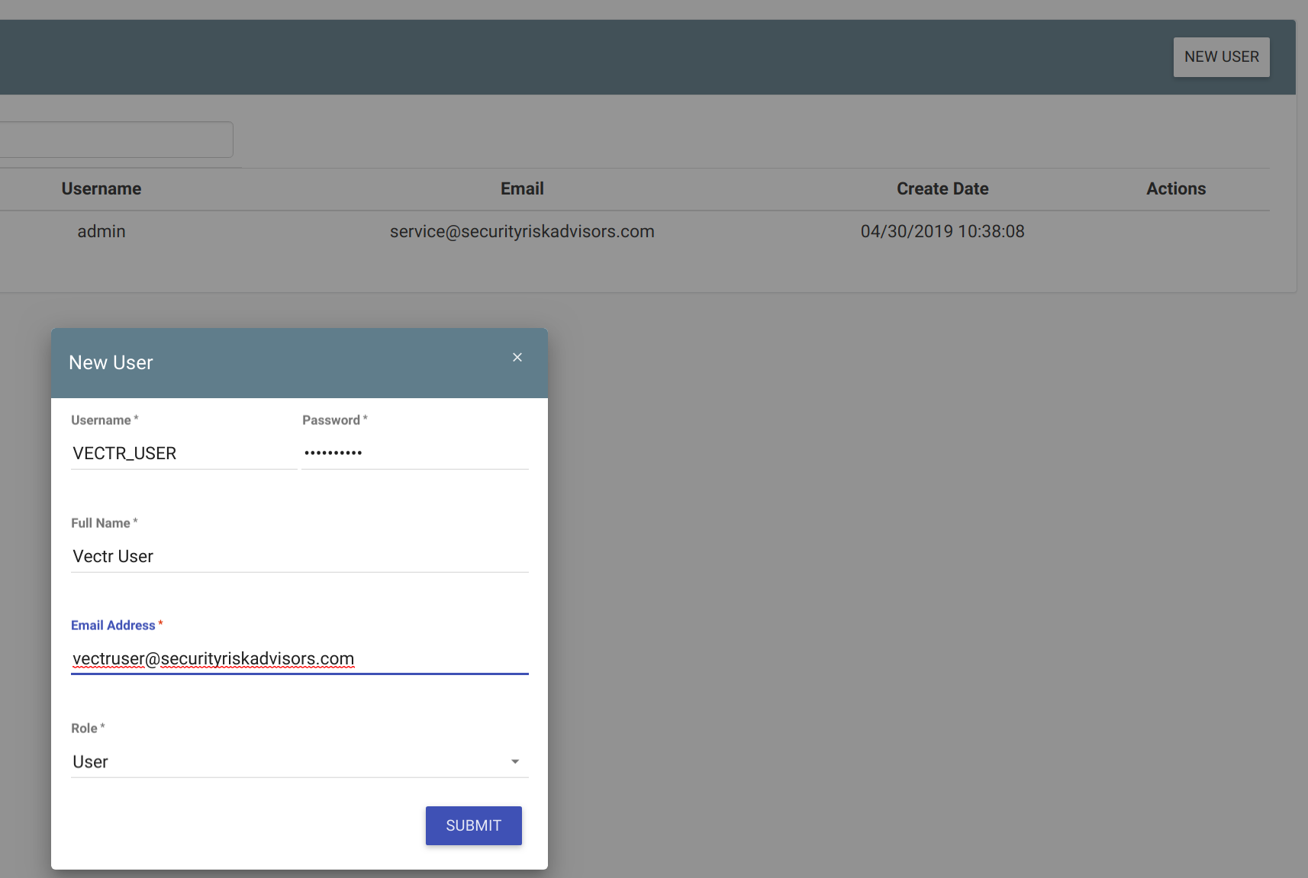

How can this feature help me?

This will allow an Administrator to grant/deny different users access to the platform.

# Tagging Management

What is it?

Allows for editing and deleting of existing system tags.

How does it work?

You can access the Tagging Management screen by selecting the Tagging tab on the Left Nav:

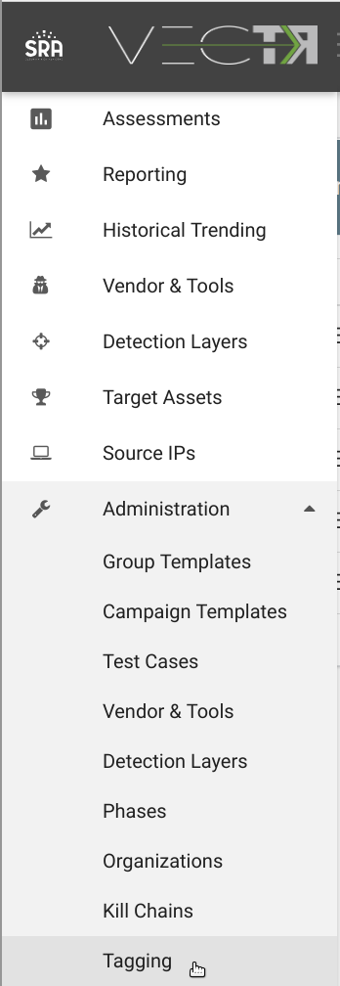

This will take you to the Tagging Management page. From here you can edit one of your Tags by clicking the cog on the right, or delete the tag by clicking the red X on the right:

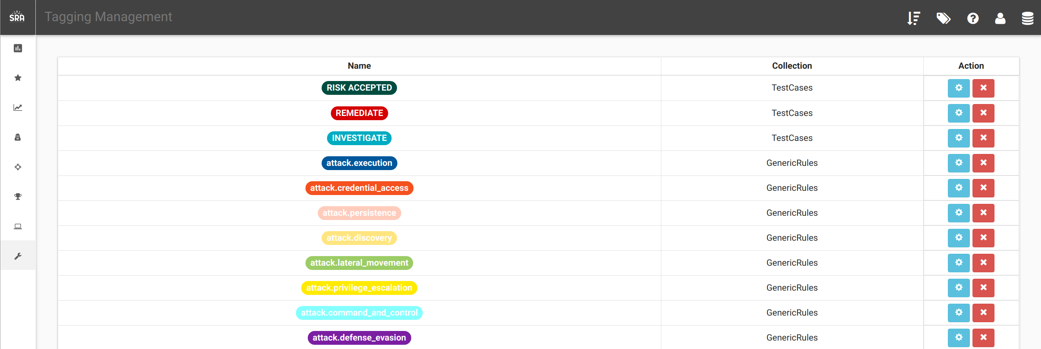

You can change the Name and Color by clicking the cog on the right. In this example, we changed the name “INVESTIGATE” tag to “INVESTIGATE_CHANGE” and color to green.

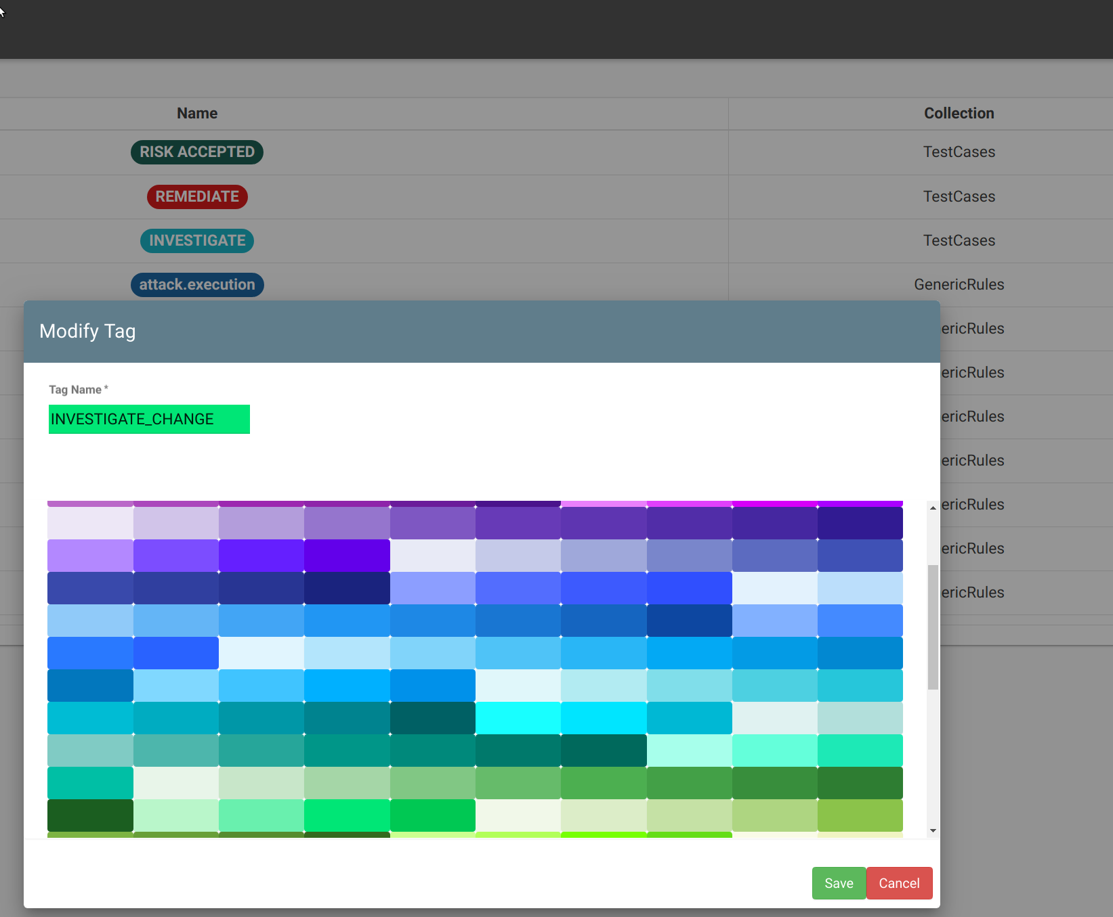

You can only delete a tag if it’s not currently in use. If you attempt to, a popup will appear informing you of the database that the tag is located in. If you navigate to that database (DB icon in the top right), then select the tag shortcut (Tag icon in the top right), you can quickly find the tagged data.

# System Flags

What is it?

Certain data has been tagged with SystemFlags. This will help guide users in areas of the app where data should not be modified, along with preventing collisions of future data deliveries.

How does it work?

Tagging of the data with a SystemFlag is done by Security Risk Advisors. We have disabled editing of fields in Administration that should only be edited within the context of a running campaign:

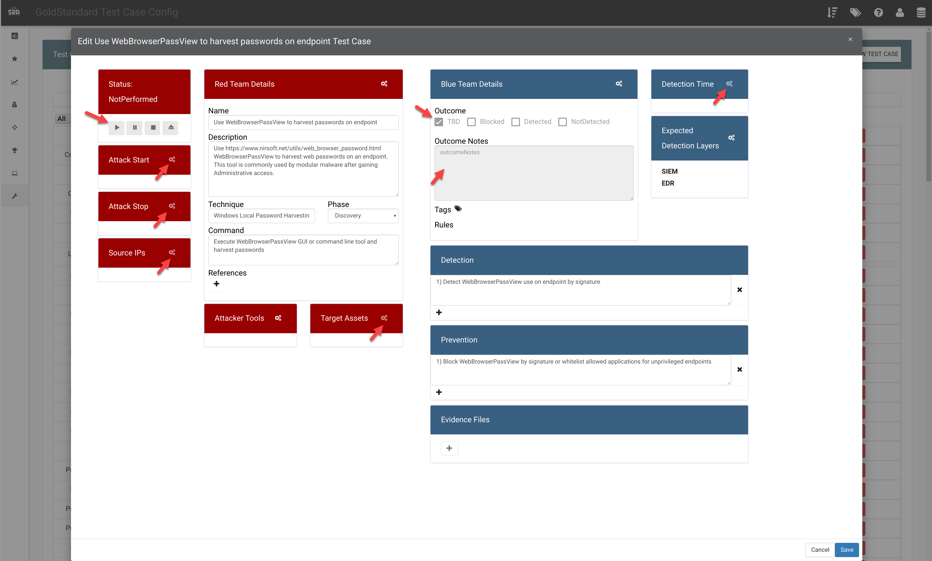

The 19 Phases that are delivered are tagged with SystemFlags, thus cannot be edited. Any newly created Phases are editable:

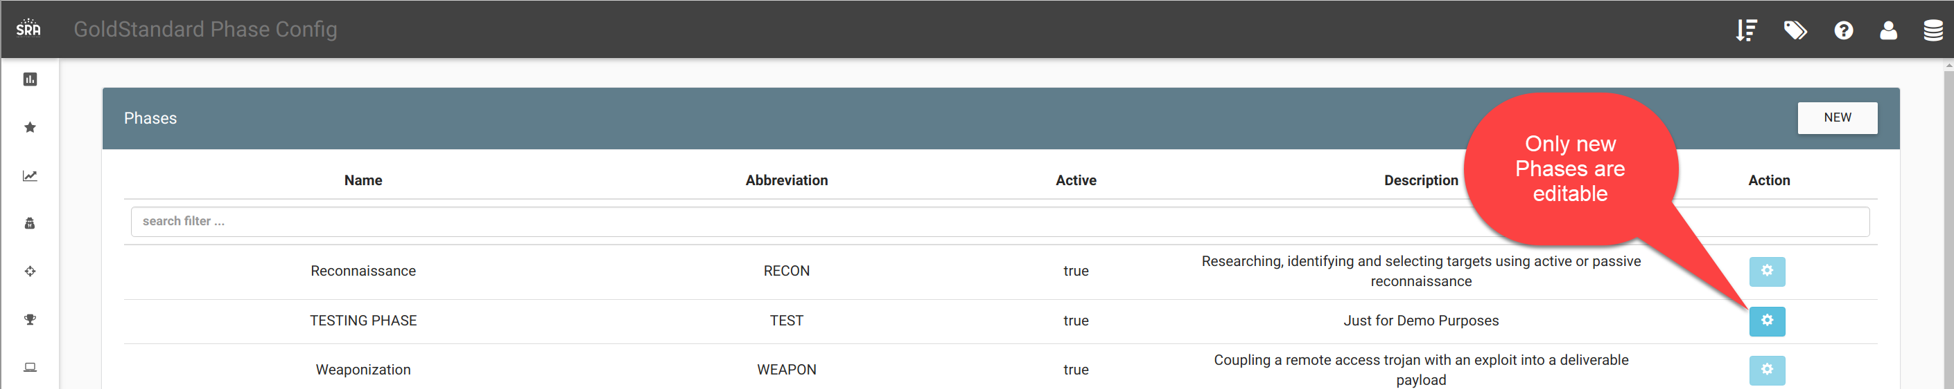

The 3 Kill Chains that are delivered are tagged as SystemFlags, thus cannot be edited. Any newly created Kill Chains are editable:

